**Paragraph:**

Our project has been designed for a sports team. There are no specifics about which sport, but it cannot be an individual sport, like tennis or golf. For data entries, we used data from the NBA. This database could be used by organizations like high-schools, universities and more. The rules for the database are as follows: A Coach has many practices and games. The team has many coaches and players. Every player and coach have a contract. Players must attend games and practices.

**ERD:**

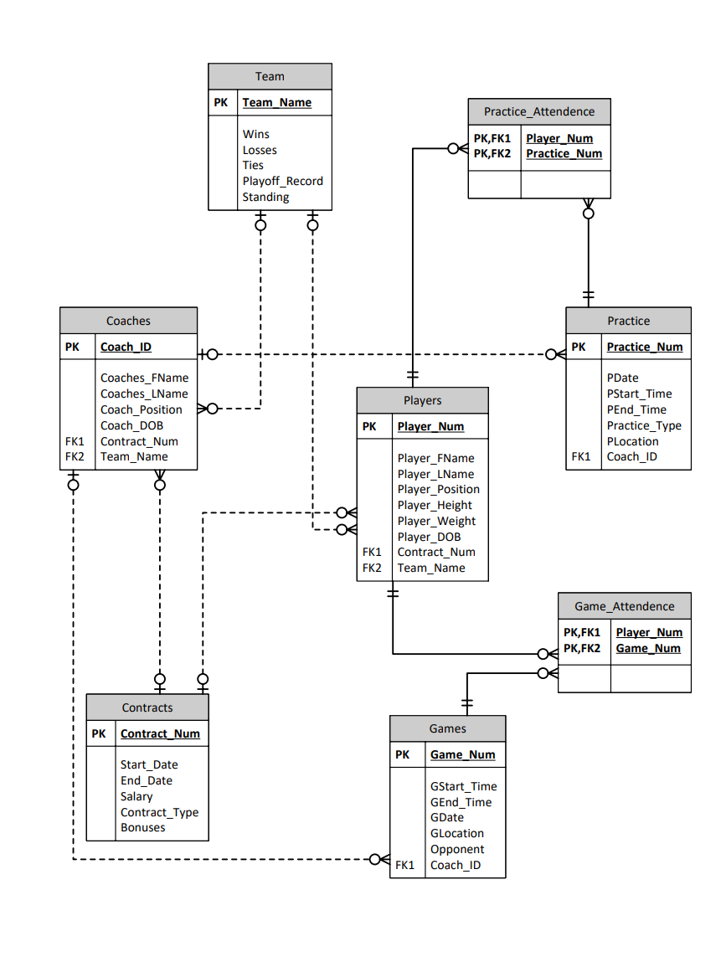

**SQL:**

create database Project1

go

-- New Query --

use Project1

go

create table Team

(

    Team_Name       char(20) primary key,

    Wins            int,

    Losses          int,

    Ties            int,

    Playoff_Record  int,

    Standing        int

)

create table Contracts

(

    Contract_Num    char(10) primary key,

    Start_Date      date,

    End_Date        date,

    Salary          money,

    Contract_Type   char(20),

    Bonuses         char(20)

)

create table Coaches

(

    Coach_ID        char(10) primary key,

    Coaches_FName   char(20),

    Coaches_LName   char(20),

    Coach_Position  char(20),

    Coach_DOB       date,

    Contract_Num    char(10)

        foreign key references Contracts,

    Team_Name       char(20)

        foreign key references Team

)

create table Players

(

    Player_Num      int primary key,

    Player_FName    char(20),

    Player_LName    char(20),

    Player_Position char(20),

    Player_Height   int,

    Player_Weight   int,

    Player_DOB      date,

    Contract_Num    char(10)

        foreign key references Contracts,

    Team_Name       char(20)

        foreign key references Team

)

create table Practice

(

    Practice_Num    char(10) primary key,

    PDate           date,

    PStart_Time     time,

    PEnd_Time       time,

    Practice_Type   char(20),

    PLocation       char(50),

    Coach_ID        char(10)

        foreign key references Coaches

)

create table Games

(

    Game_Num        char(20) primary key,

    GStart_Time     time,

    GEnd_Time       time,

    GLocation       char(30),

    Opponent        char(20),

    Coach_ID        char(10)

        foreign key references Coaches

)

create table Game_Attendence

(

    Player_Num      int

        foreign key references Players,

    Game_Num        char(20)

        foreign key references Games,

    primary key (Player_Num, Game_Num)

)

create table Practice_Attendence

(

    Player_Num      int

        foreign key references Players,

    Practice_Num    char(10)

        foreign key references Practice,

    primary key (Player_Num, Practice_Num)

)

-- New Query --

use Project1

go

INSERT INTO Team VALUES

    ('Warriors',53,29,10,32,1),

    ('Mavericks',52,30,5,24,3),

    ('Lakers',52,19,10,60,2),

    ('Celtics',51,31,7,72,4),

    ('Cavaliers',44,38,9,22,5)

INSERT INTO Contracts VALUES

    (574,'04-04-2020','04-04-2022',75000000,'Two-Years','None'),

    (676,'02-08-2020','02-08-2022',70000000,'Two-Years','Yes'),

    (476,'01-27-2018','01-27-2022',140000000,'Four-Years','Yes'),

    (342,'07-15-2020','07-15-2022',90000000,'Two-Years','None'),

    (290,'05-03-2018','05-03-2022',1700000000,'Four-Years','Yes')

INSERT INTO Coaches VALUES

    ('200','Steve','Kerr','Head Coach','09-27-1965','342','Warriors'),

    ('201','Jason','Kid','Head Coach','03-23-1973','342','Mavericks'),

    ('202','Darvin','Ham','Head Coach','07-23-1973','574','Lakers'),

    ('203','Joe','Mazzulla','Head Coach','06-30-1988','574','Celtics'),

    ('204','John-Blair','Bickerstaff','Head Coach','03-19-1979','676','Cavaliers')

INSERT INTO Players VALUES

    (30,'Stephen','Curry','Point Guard',190,185,'03-14-1988','290','Warriors'),

    (77,'Luka','Dončić','Point Guard',200,230,'02-28-1999','290','Mavericks'),

    (06,'LeBron','James','Small Forward',205,250,'12-30-1984','290','Lakers'),

    (00,'Jayson','Tatum','Small Forward',203,210,'03-03-1998','342','Celtics'),

    (31,'Jarret','Allen','Center',210,243,'04-21-1998','574','Cavaliers')

INSERT INTO Practice VALUES

    ('01','05-23-2022','13:30:00','16:30:00','Conditioning','1011 Broadway, Oakland',200),

    ('02','06-01-2022','08:00:00','10:30:00','Shooting','1520 Inspiration Dr, Dallas',201),

    ('03','05-10-2022','16:00:00','18:00:00','Dribbling','2275 East Mariposa Ave, El Segundo',202),

    ('04','06-10-2022','09:30:00','11:30:00','Scrimmage','840 Winter St, Waltham',203),

    ('05','06-01-2022','13:30:00','16:30:00','Shooting','6101 Brecksville Road, Independence',204)

INSERT INTO Games VALUES

    ('30000','16:00:00','18:00:00','Chase Centre','Nets',200),

    ('30060','18:30:00','20:30:00','American Airlines Center','Knicks',201),

    ('30070','10:00:00','12:00:00','Crypto.com Arena','Heat', 202),

    ('30080','12:00:00','14:00:00','TD Garden','Nuggets', 203),

    ('30090','14:00:00','16:00:00','Rocket Mortgage FieldHouse','Spurs', 204)

INSERT INTO Game_Attendence VALUES

    ('30','30000'),

    ('77','30060'),

    ('06','30070'),

    ('00','30080'),

    ('31','30090')

INSERT INTO Practice_Attendence VALUES

    ('30','01'),

    ('77','02'),

    ('06','03'),

    ('00','04'),

    ('31','05')